What is Neurosurgery: When Is It Necessary and What Are the Risks? – H1
P1 | what is brain surgery
P2 | types of brain surgery
P2 | brain surgery procedure
P2 | neurosurgery benefits and risks
P1 | what is neurosurgery
P2 | benefits of brain surgery
P2 | best neurologists in pune

URL Slug: what-is-neurosurgery
Title: What is Neurosurgery? Necessity & Risks Explained | ABMH Pune
Description: Explore neurosurgery, a field addressing brain, spine, and nerve disorders with tailored treatments for all ages. Discover how it restores neurological health
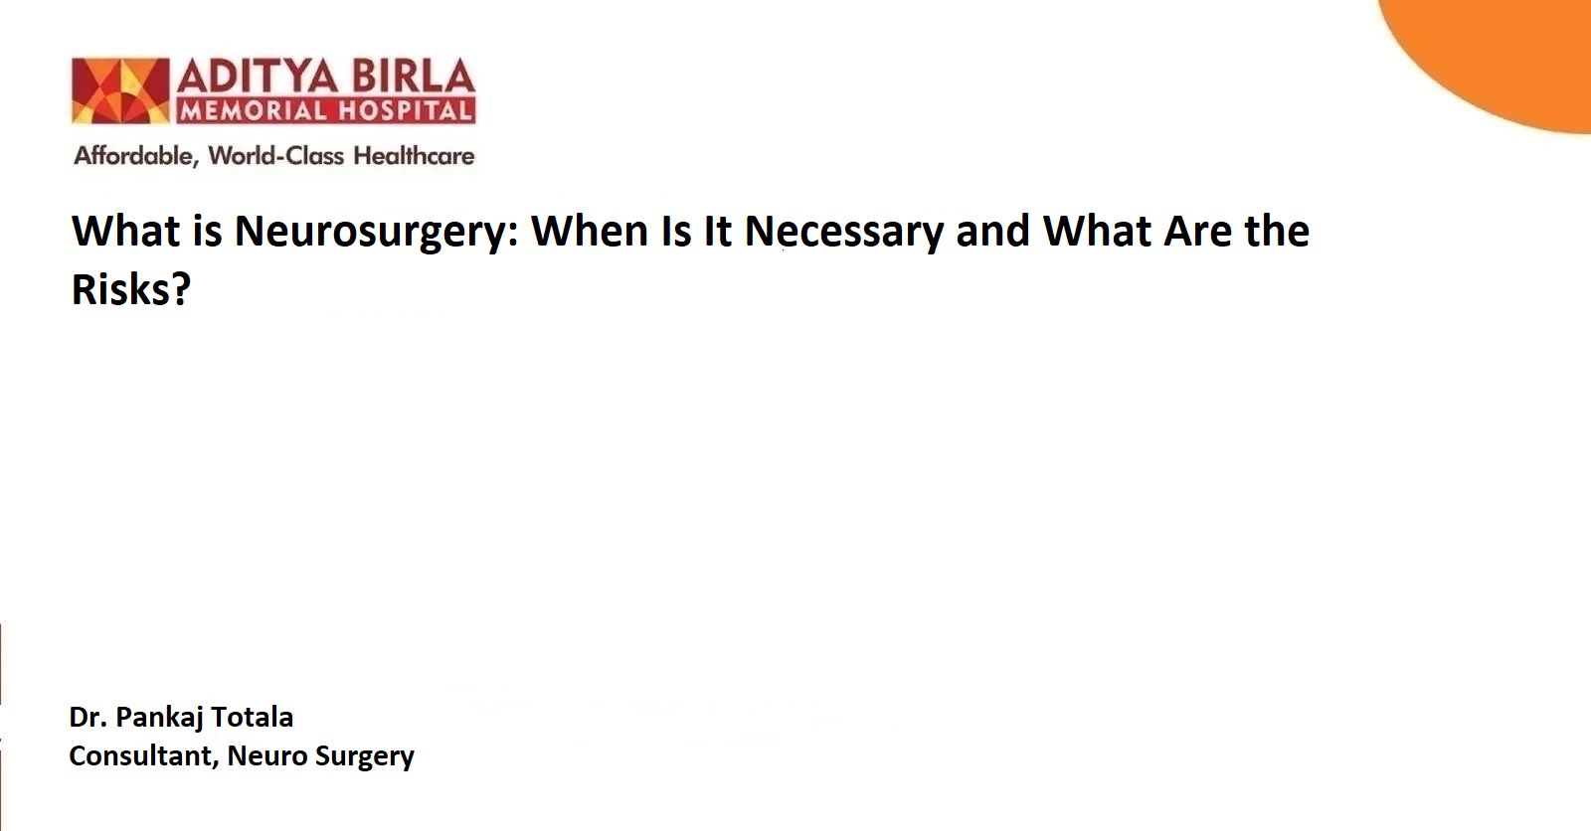

Neurosurgery is often associated with brain surgery, but its scope extends far beyond that! This specialised medical field focuses on diagnosing and treating patients with injuries, diseases, or disorders affecting the brain, spinal cord, spinal column, and peripheral nerves throughout the body.
Neurosurgeons care for both adult and pediatric patients, tailoring their approach based on the specific condition or injury. Their expertise encompasses both surgical and non-surgical treatments, depending on the patient’s needs. From intricate brain procedures to addressing spinal and nerve-related disorders, neurosurgery plays a critical role in restoring and improving neurological health.
What is Neurosurgery? – H2
Neurosurgery is a medical speciality that involves surgical intervention for conditions affecting the brain, spine, and peripheral nerves. Neurosurgeons are extensively trained professionals who specialise in diagnosing and treating neurological disorders.
Brain surgery is one of the most intricate aspects of neurosurgery. It involves delicate procedures for various medical conditions, including tumours, injuries, and diseases. Neurosurgery is not limited to the brain and includes procedures for spinal disorders, such as herniated discs and spinal stenosis.
When is Brain Surgery Necessary? – H2
Brain surgery is often recommended when non-invasive treatments fail to resolve the issue or when immediate intervention is critical to saving a patient’s life or preventing long-term damage. Common reasons for brain surgery include:
- Brain Tumours: Removal of cancerous or benign growths affecting brain function.
- Traumatic Brain Injuries: Treating fractures or severe head injuries.
- Stroke: Addressing haemorrhages or blockages.
- Epilepsy: Reducing seizure frequency or severity.
- Aneurysms: Repairing or removing weakened blood vessel walls.
- Hydrocephalus: Relieving fluid pressure within the brain.
Understanding the specific condition requiring surgery can help patients prepare mentally and physically for the procedure.
Types of Brain Surgery– H2
Neurosurgery encompasses various procedures tailored to the patient's specific condition. The major types of brain surgery include:
- Craniotomy – H3
This procedure involves removing a part of the skull to access the brain. It is often performed to remove tumours, repair aneurysms, or treat trauma. After the procedure, the removed skull segment is replaced.
- Endonasal Endoscopic Surgery – H3
A minimally invasive approach where a surgeon accesses the brain through the nasal cavity. This technique is commonly used to treat pituitary tumours or skull base tumours.
- Deep Brain Stimulation (DBS) – H3
Used for treating conditions like Parkinson’s disease and epilepsy, DBS involves implanting electrodes in specific areas of the brain to regulate abnormal activity.
- Biopsy – H3
A small tissue sample is taken from the brain to determine if it’s cancerous or to identify infections or inflammation.
- Shunt Surgery – H3
A procedure to drain excess cerebrospinal fluid from the brain to relieve pressure caused by hydrocephalus.
Each type of brain surgery is associated with specific goals and methodologies chosen based on the patient’s condition and overall health.
Brain Surgery Procedure – H2
Understanding the brain surgery procedure can help reduce anxiety and prepare patients for what to expect. The steps generally include:
- Diagnosis and Imaging – H3
The process begins with a thorough diagnosis, often involving MRI, CT scans, or angiography to visualise the issue.
- Pre-Surgical Preparation – H3
Patients are given instructions about medications, fasting, and other preparations. General anaesthesia is typically administered to ensure the patient remains unconscious during surgery.
- Surgical Intervention – H3
Neurosurgeons use precise tools and advanced techniques to operate on the brain. Depending on the type of surgery, it may involve removing tumours, repairing blood vessels, or inserting medical devices like electrodes.
- Post-Surgery Monitoring – H3
After the procedure, patients are closely monitored in the ICU to ensure proper recovery. Rehabilitation may involve physical therapy, occupational therapy, or speech therapy, depending on the surgery’s impact.
Neurosurgery Benefits and Risks – H2
Neurosurgery offers significant benefits but also carries certain risks due to its complexity.
Benefits of Brain Surgery – H3
- Life-Saving Interventions: Procedures like tumour removal or aneurysm repair can save lives.
- Symptom Relief: Neurosurgery often alleviates debilitating symptoms such as chronic headaches, seizures, or nerve pain.
- Improved Quality of Life: Restoring normal brain function can help patients regain independence and lead more fulfilling lives.
- Minimally Invasive Options: Advances in technology allow for procedures with reduced recovery time and minimal scarring.
Risks of Brain Surgery – H3
- Infection: Any surgical procedure carries a risk of infection.
- Bleeding or Blood Clots: These complications can arise during or after surgery.
- Neurological Deficits: Temporary or permanent issues such as memory loss, speech difficulties, or paralysis may occur.
- Reaction to Anaesthesia: Some patients may experience complications from anaesthesia.
- Long Recovery Times: Depending on the surgery, recovery can take weeks or even months.
While the risks are real, the decision to undergo brain surgery is often a balance between the potential benefits and the urgency of the medical condition.
When to Consult a Neurosurgeon? – H2
If you experience persistent symptoms such as severe headaches, seizures, memory loss, or difficulty with motor functions, consult a neurologist or neurosurgeon. Early diagnosis and intervention can significantly improve outcomes.
In Pune, you can consult some of the best neurologists in Pune at renowned hospitals like Aditya Birla Memorial Hospital. These experts specialise in neurosurgery and are equipped to provide advanced diagnostic and treatment options.
How to Choose the Right Neurosurgeon? – H2
Selecting the right neurosurgeon is critical for achieving the best results. Consider the following factors:
- Look for a neurosurgeon with expertise in your specific condition.
- Verify their qualifications and affiliations with reputable medical institutions.
- Choose a hospital equipped with advanced surgical tools and post-operative care.
- Read testimonials to understand the experiences of other patients.
Prevention and Lifestyle Tips – H2
While not all conditions requiring neurosurgery can be prevented, certain lifestyle changes can reduce the risk of neurological disorders:
- Maintain a Healthy Lifestyle: Regular exercise and a balanced diet rich in fruits, vegetables, and omega-3 fatty acids can promote brain health.
- Avoid Head Injuries: Use helmets when engaging in high-risk activities.
- Manage Stress: Chronic stress can affect brain function. Practice mindfulness or meditation to stay relaxed.
- Stay Informed: Regular check-ups and early screening can help detect issues before they become severe.
Conclusion – H2
Advances in surgical techniques and technology have made neurosurgery safer and more effective than ever before. Whether you’re facing a condition like a brain tumour or considering a consultation with the best neurologists, early intervention and expert care can make a significant difference in outcomes. Always consult with your doctor to determine the best course of action for your needs.
Frequently Asked Questions (FAQs) – H2
- What types of conditions do neurosurgeons treat? – H3
Neurosurgeons address a wide range of issues, including brain tumours, spinal cord injuries, epilepsy, Parkinson’s disease, and nerve disorders like carpal tunnel syndrome.
- Are all neurosurgeries performed with open surgery? – H3
No, many neurosurgeries today are performed using minimally invasive techniques such as endoscopic or robotic-assisted procedures, reducing recovery time and risks.
- What should I expect during recovery from neurosurgery? – H3
Recovery varies based on the procedure, but it typically includes a combination of rest, physical therapy, and follow-up visits to ensure proper healing and function.
- Do neurosurgeons only perform surgery? – H3
Not necessarily. Neurosurgeons often provide non-surgical treatments such as medications, physical therapy, or interventional procedures to manage neurological conditions.
- How do I prepare for a neurosurgery consultation? – H3
Bring your medical history, previous test results, and a list of questions or symptoms. Being well-prepared helps the neurosurgeon assess your condition more effectively.

References: – H2
- Williams NR, Okun MS. Deep brain stimulation (DBS) at the interface of neurology and psychiatry. Journal of Clinical Investigation. 2013 Nov 1;123(11):4546–56.
- Department of Neurological Surgery. What is Neurosurgery? | OHSU [Internet]. Ohsu.edu. 2017. Available from: https://www.ohsu.edu/school-of-medicine/neurosurgery/what-neurosurgery
- Kalfas I. Neurological Surgery [Internet]. ACS. Available from: https://www.facs.org/for-medical-professionals/education/programs/so-you-want-to-be-a-surgeon/section-iii-surgical-specialties/neurological-surgery/

